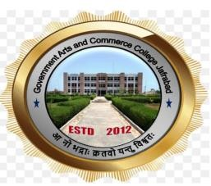

GOVERNMENT ARTS AND COMMERCE COLLEGE, JAFRABAD

‘STUDENT SENSITIZATION SEMINAR ON SSIP’

REPORT OF SEMINAR HELD ON 15TH FEBRUARY, 2024

COMMITTEE SSIP

Co-ordinator Principal
Prof Yamuna Panicker Dr. Viralkumar Shilu

Objective of the Seminar
The Student Startup and Innovation Committee of the college conducted the Seminar. Following were the major Objectives of the Seminar.
- Acquaint the students about the idea of a STARTUP.
- To explain the difference between a regular business and STARTUP
- To inform the students about the Startup Policy of the Government of Gujarat
- To explain the procedure to apply for SSIP grant
- To solve the doubts of students regarding STARTUP and SSIP policy

About the Resource Person

About the Seminar

At the beginning Prof. Yamuna Panicker-Coordinator, SSIP, welcomed the participants to the event and the programme, Thereafter, Dr. Viralkumar Shilu, Principal welcomed the guest speaker Dr. Jignesh Vaja.
Dr. Jignesh Vaja delivered the lecture with the help of a PowerPoint presentation. He started with explaining the students the meaning of a Startup. He explained essentially how a startup differs from a normal business setup. The various stages of startup were clearly explained to the students. He further gave various examples of successful startups and some potential startup ideas.
Finally questions from the participants were welcomed. Prof Yamuna Panicker gave the Vote of Thanks.

